Pick one from the list below.

Each file should be a python program, root file name of “Lab10_pcarswel-#”, extended by ".py". Insert your username for pcarswel and the number of the question you chose for ‘#’. The header of each file should be a triple-quoted comment (a docstring) which will include the name of the program, your name [the author], What is the purpose of the program, and the date. Double-check that you have included all of the verbal in-class modifications or additional requirements based on the class progress, and you have double checked that you are meeting the rubric.

Word Count: Count the frequency of each word in a text file. Let the user choose a filename to read.
  - The program will count the frequency with which each word appears in the text.
  - Words which are the spelled the same but differ by case will be combined.
  - Punctuation should be removed
  - If the file does not exist, use a ‘try-exception’ block to handle the error
  - Output will list the words alphabetically, with the word in the first column and the count in the second column … i.e. as : 1287
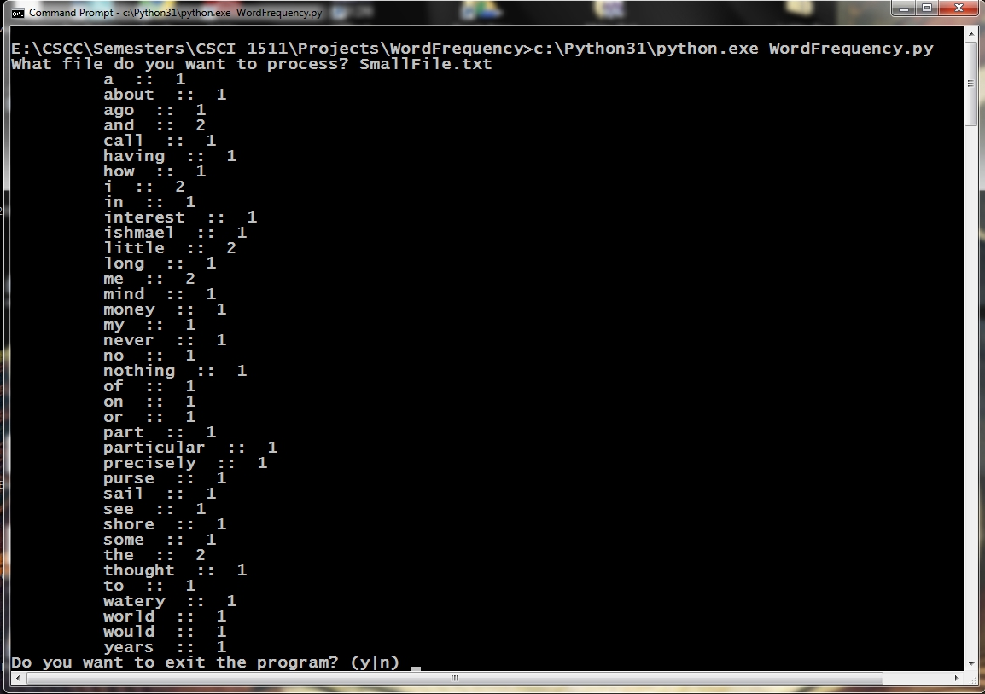
Word Frequency Example 1

The IPO chart is listed as:
IPO Chart for the main() function
Input | Processing | Output
NONE | - Gets the filename from the user and creates the file pointer  - catches the exception if a file does not exist | NONE
IPO Chart for the wordFreq() function
File pointer | - creates the data type to store the word and the frequency  - eliminate punctuation  - combine the same words that differ by uppercase characters | Word frequency data??
IPO Chart for the printOut() function
Word count data | - Prints out the word and it's frequency | NONE
IPO for WordFrequency.py

Pseudocode for Word Count:
Psuedo Code

printWds(data)
## print each word in our data and the respective count
## but we need them sorted, dictionaries have a nice module, sorted
## and lists have sort.
for x in sorted(data.keys()):
print() ## look at the formatting above
return

wordFreq(fptr)
## create empty data type, dictionary or list?
freq = {} or freq = []

## read in the first line
line = fptr.readline()
punctChars = (….create a tuple of punctuation characters to eliminate… )
while line:
for c in punctChars:
## use the string replace module to substitute an empty char
line = line.replace(c, “”)
## create a list of separate words that make up the string
words = line.split()

for each word in our split:
#create a temporary word converted to lower using the lower()
tmp = word.lower()
## add this to your database, this is where dictionaries have the
## advantage over dictionaries … the get() method
freq[tmp] = freq.get(tmp, 0) + 1

read another line
return freq

